Kotlin – Basic Types
Kotlin’s basic types are designed to be intuitive and powerful, behaving like objects while offering performance similar to Java primitives. Here's a breakdown of the core categories:
- Numbers
Kotlin supports both signed and unsigned number types:
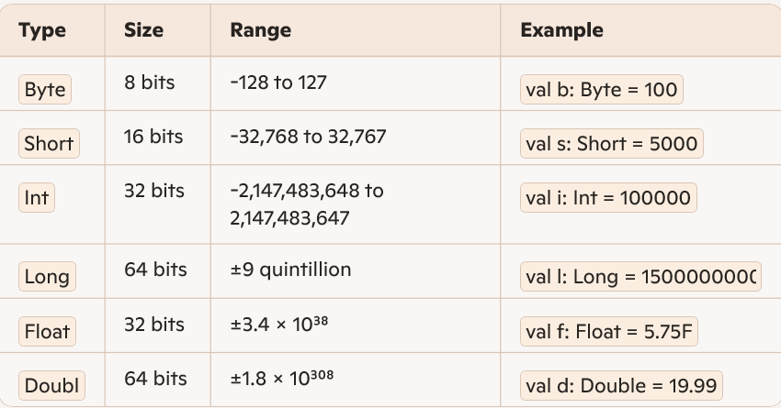
Unsigned types like UByte, UShort, UInt, and ULong are also available.

- Boolean
Represents logical values: true or false
val isActive: Boolean = true
- Characters
Single Unicode characters enclosed in single quotes.
val letter: Char = 'A'

- Strings
Immutable sequences of characters. Kotlin treats strings as objects with built-in methods.
val name: String = "Vinu"
println(name.length) // Accessing property

- Arrays
Fixed-size collections of elements of the same type.
val numbers = arrayOf(1, 2, 3) val chars = charArrayOf('a', 'b', 'c')

